**Briefing Document: *Linkages between climate change, violence and Boko Haram in the Lake Chad Region***

*Abdul-Majeed Ibrahim - Yale School of Forestry and Environmental Studies*

*Lauren Wyman - Yale Jackson Institute for Global Affairs*

***Abstract****:*

Lake Chad is a source of life and livelihoods for 30 million people in Nigeria, Chad, Cameroon and Niger. However, anthropogenic stressors compounded by climate change have shrunk the lake in recent decades, contributing to over-exploitation, resource scarcity, loss of livelihoods and conflict over land and water. This fragile humanitarian situation exacerbates the risks posed by the Boko Haram militancy, as already vulnerable populations are forced off of their land and flee. This vulnerability also contributes to strengthening Boko Haram, as soldiers may be tempted to join out of economic necessity. Any policy intending to reintegrate Boko Haram fighters into civilian society must consider the humanitarian and ecological context at play: livelihoods are drying up in northeastern Nigeria, along with the lake.

***Key words:***climate change, adaptation, desertification, livelihood loss, gender, Lake Chad, violence

***Background and context***

Lake Chad is the largest lake in Central and West Africa, bordered by four countries – Nigeria’s northeast, Cameroon’s far north, Chad’s Lac region (western Chad) and Niger’s southeast.[1] The Lake Chad basin encompasses 966,955 km2 of floodplains, wetlands and aquifers.[2] The population in the Lake Chad region has more than doubled over the last decade and about 30 million people in the basin depend on the lake for their livelihoods.[3] Subsistence fishing, agriculture and livestock farming are the primary economic activities in the region, which is a hub for trade and commerce.

In the last six decades, the lake has been shrinking, and along with it the lives and livelihoods of the region’s population. The lake presently covers 1,350km2, only one twentieth the area it covered in the 1960s.[4] The United Nations Environmental Programme attributes 50 percent of the lake decrease in size to overuse by humans for irrigation and the rest from changing climate and rainfall patterns.[5] Historic data shows that the lake has recovered from shrinking on multiple occasions, but scientists doubt this will occur due to anthropogenic stressors and climate change.[6]

***Impact of anthropogenic stressors and climate change***

Over the last half-century, Lake Chad has been shrinking due to over-exploitation and manipulation by national governments and by local populations (see Figure 1). In particular, damming of source rivers like the Chari River and the Komadugu-Yobe for irrigation and fresh water use have interrupted the lake’s natural flow regime. Additionally, overgrazing, land-clearing for agriculture and poor farming practices have reduced basin soil quality and water retention, thus putting undue pressure on the basin’s natural resources.[7] An over reliance on extractive practices like fishing has led to biodiversity loss in the lake and decreased system resilience. As the population living around the lake has increased rapidly over the past decade, due to high fertility as well as forced migration, competition for the lake’s resources has made it nearly impossible for the lake to recover on its own.[8]

Climate variability, shocks and long-term changes compound the human-derived environmental degradation in the Lake Chad basin. Specifically, the Lake Chad Basin is one of the most climate-sensitive regions on the African continent. There is high inter-annual rainfall variability, and the average yearly rainfall has decreased over the last century.[9] The region alternates between periods of high rainfall and flooding and drought, which makes agriculture and pastoral livelihoods highly vulnerable. Temperature increases in the region over the last forty years have reached up to 6 degrees C during the dry season.[10] This is compounded by desertification, which is encroaching in the northern part of the lake.[11] Over the course of this century, increasing temperatures and evapotranspiration of the Lake will reduce available water by up to 10 percent.[12] Climate models predict a shift in ecosystem composition around the lake, with arable lands decreasing by up to 135,000 km2 by 2099.

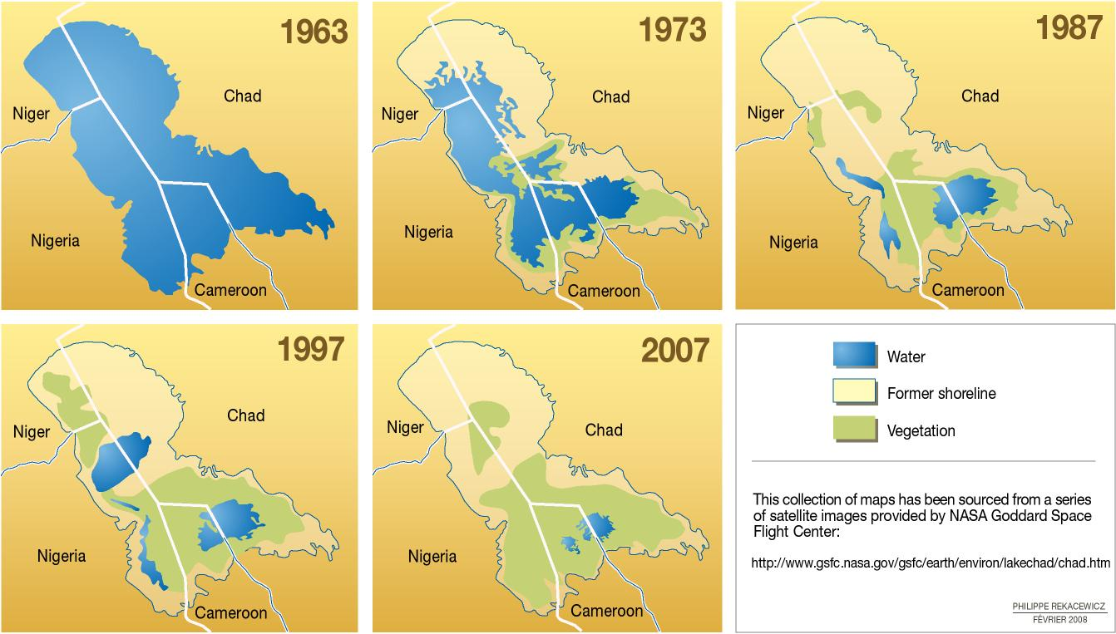

Figure 1: Chronology of Lake Chad variability: 1960 to 2007. Image source: NASA

***Conflict Over Shrinking Natural Resources***

Seasonal fluctuations - recession and inundation of the floodplains - makes the lake a good habitat for fish as well as fertile ground for farming. Lake recession exposes the lake bed’s fertile soils for farming; and during inundation, nutrients are restored to the soil. Flood recession cropping is a major production system in the Lake Chad Basin where farmers mostly cultivate sorghum and bereber.[13]

The shrinking of the lake has created tensions among competing resource users - fishers, farmers, and cattle herders. Farming activities on the exposed lake bed modifies aquatic community in the lake.[14] Specifically, ploughing close to the lake increases siltation and eutrophication, reducing lake depth and causing fish kills from algae blooms.

The modified aquatic ecosystem alters species biodiversity and the number of fish species that are able to inhabit the lake. Fish are able to evade fishers’ fishing nets by hiding under marshes and tall grasses growing in the lake due to the siltation. Fishing thus becomes difficult and fishermen lose their fishing gear to mash weeds. In response to this pressure, fishermen start to disregard national boundaries and migrate towards other national territories to fish.[15] Some fishermen turn to farming to take advantage of the exposed fertile lake bed, which contributes to competition for farmland with traditional farmers. Adding to the mix, pastoral communities clash with farmers as traditional pasture lands have been encroached by farmers and, likewise, cattle often destroy farmland through trampling when they move to drink water from the lake. Farmers, fishers and cattle herders migrate towards and compete for the shrinking lake’s resources without regard for the imaginary boundary lines. Resource extraction has intensified as a result and crude methods are being used in resource extraction to maximize output.

***Climate Change as a Threat Multiplier for Violent Extremism in the Region***

Boko Haram has taken advantage of porous borders of the Lake Chad basin countries and expanded to Cameroon’s far north, Niger’s southeast, and Chad’s Lac region[16]. Suicide bombing and raids on communities have displaced an estimated 2.3 million people (as of November 2016) in the Lake Chad basin region, of which 1.9 million are in Nigeria’s northeast[17]. By displacing primarily agricultural populations, the insurgency exacerbates climate-driven food shortages and thus the fragile food and nutrition security situation of the region, where 6.3 million people are food insecure as of August 2016.[18] Boko Haram interferes with markets and transportation infrastructure, thus further complicating food shortages and access of vulnerable populations.

Communities hosting internally displaced persons (IDPs) face resource competition and overuse as the influx of people exacerbates food, shelter and livelihood needs.[19] Forced displacement in this context strips victims of their social and physical capital and networks, undermining their ability to cope with the conflict and also to a changing climate.[20] Women and children are particularly vulnerable in this context, often subjected to sexual and gender-based violence, forced into slavery and marriage.

The impacts of resource scarcity and the humanitarian crises in the region are cyclical, however, as lack of economic opportunity and the prevalence of hunger has led to many Nigerians joining Boko Haram. In fact, some foot soldiers in the Boko Haram sect have been identified as people displaced by severe drought in the regions[21]. While Boko Haram started in urban areas, hunger and natural resource competition may have contributed to young Boudouma men joining the group.[22] See Figure 2 for a schematic on how Boko Haram contributes to, and is exacerbated by, the humanitarian and climate situation in the Lake Chad Basin.

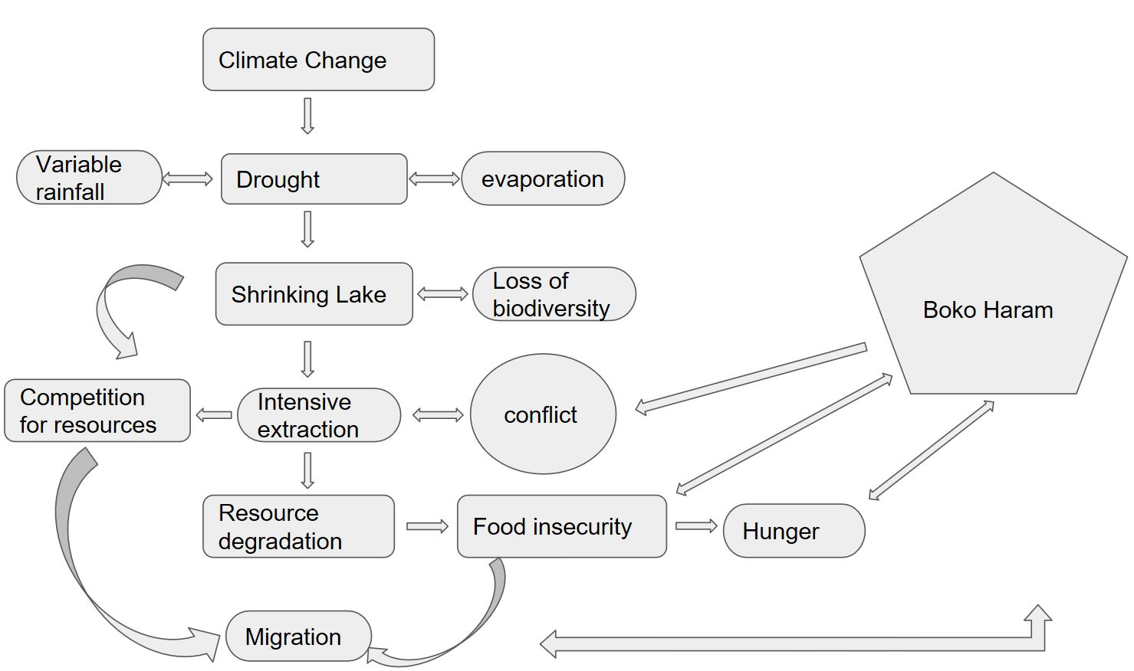

***Figure 2:* Variable rainfall patterns lead to drought and lake shrinkages, resulting in biodiversity loss and heightened competition for the lake’s dwindling natural resources and local conflict. Resource users begin to use crude methods to extract resources and migrate across borders. Intensive extraction degrades natural resources, leading to reduced agricultural output and local food insecurity. Boko Haram displaces large swaths of the population, contributing to food insecurity. Young men join Boko Haram for economic reasons (hunger, lack of opportunities). Conflict among resource users leads to unstable region, which is exploited by Boko Haram.**

***National and Regional Environmental Policies and Management Bodies***

President Buhari has made climate change a national priority for Nigeria - promoting sustainable growth while reducing carbon dioxide emissions on the international, federal, regional and local levels, across sectors.[23] However, there are gaps in climate change adaptation coverage, particularly on the local level, and in the security and defense sectors.

On an international level, Nigeria is party to the UN Framework Convention on Climate Change (UNFCC) and signed the Paris Accords in September 2016. On a federal level, Nigeria has a national bureaucratic infrastructure for environmental protection, including Nigeria’s Climate Change Policy and the national development plan, Vision 2020.[24]

On a regional level, the government of Nigeria has partnered with nine West African countries to develop sustainable regional climate change policy and research, through the West African Science Service Centre on Climate Change and Adapted Land Use (WASCAL).[25] The Lake Chad Basin Commission (LCBC) founded in 1964, is a regional mechanism to settle natural resource disputes, promote conservation and regional development and peace and security in the region. However, the LCBC has struggled to carry out its mandate due to lack of funding and technical capacity.[26] Additionally, there is little cooperation between the four countries on lake resource management.[27]

On a local level, there are a variety of adaptation projects spearheaded by regional organizations like the Lake Chad Basin Commission, such as the organization’s Development and Climate Action Plan . However, the implementation of consistent Nigerian governmental climate change adaptation projects in conflict zones, particularly in the northeast, have fallen short due to lack of adequate infrastructure, political will and the presence of Boko Haram. While Nigerian policy recognizes the intersectionality between the current conflict with Boko Haram and natural resource clashes due to climate change, it lacks political impetus to approach defense and security issues with a climate change adaptation lens.[28]

**Concrete recommendations:**

1. **Shift national and international dialogue about counter-terrorism.** Current discourse on counterinsurgencies overemphasizes security, failing to account for local economies, social welfare, education, food supply, and social relations between the governments and the people[29]. Currently the Lake Chad Basin is going through a food crisis, with millions vulnerable to food insecurity in the region. **It is therefore vital that any counter-terrorism strategy is adaptive to the humanitarian situation on the ground, promoting food security, local economic growth and livelihood opportunities.**
2. **Build strong institutions.** It’s vital to support good governance and governmental institutions at the local, regional and national levels, to provide social services like education and healthcare, particularly for children, youth and women. Additionally, our recommendation should support institutions to provide psycho-social services, particularly for women victims of sexual and gender-based violence.
3. **Support environmental conservation efforts through the Lake Chad Development and Climate Resilience Action Plan.** It’s important to work with the Lake Chad Basin Commission to implement its *Development and Climate Action Plan,* to support conservation and livelihoods on the basin/watershed level and to build community resilience through the provision of technical assistance on best farming, fishing and grazing practices.

1. **Apply a climate change lens to reintegration programs.** The government of Nigeria should push to further incorporate the climate change lens into conflict and peacebuilding policies and actions in northeastern Nigeria. Failing to consider the impact of climate change on livelihoods when demobilizing Boko Haram fighters and providing them with vocational training - as through the current Operation Safe Corridor model - may drive them back into the organization. **Developing climate resilient livelihoods** for not only ex-Boko Haram fighters but all people in the northeast, which is the most impacted region from climate change and desertification, **is vital to insure a stable, sustainable peace.**

***Bibliography:***

* Babamaaji, R.A. & Lee, J. (2014). Land use/land cover classification of the vicinity of Lake Chad using Nigeria Sat-1 and Landsat data. Environ Earth Sci 71: 4309. doi:10.1007/s12665-013-2825-x
* Comolli, V. (2015) The regional problem of Boko Haram. *Survival: Global Politics and Strategy* 109-117 Accessed from<http://www.iiss.org/en/publications/survival/sections/2015-1e95/survival--global-politics-and-strategy-august-september-2015-c6ba/57-4-07-comolli-cm-7fd1>
* GIZ (2015). Adaptation to Climate Change in the Lake Chad Basin: Climate Change Study. <https://www.giz.de/en/worldwide/24845.html>
* Mayah E. (2012) Strict border controls has led to high commodity prices Accessed from<http://www.africareview.com/news/Climate-change-fuels-Nigeria-terrorism/979180-1334472-4m5dlu/index.html>
* Ngatcha, B. Ngounou (2009). Water Resources Protection in the Lake Chad Basin in the Changing Environment. European Water 25/26: 2-12. <http://www.ewra.net/ew/pdf/EW_2009_25-26_01.pdf>
* Okpara, U. T. et al (2015) Conflict about water in Lake Chad: Are environmental, vulnerability and security issues linked? *Progress in Development Studies* 15 (4): 308 – 325 Accessed from<http://pdj.sagepub.com/content/15/4/308.full.pdf+html>
* Sayne, Aaron. 2009. Special Report: Climate Change Adaptation and Conflict in Nigeria. United States Institute of Peace. Link: <https://www.usip.org/sites/default/files/Climate_Change_Nigeria.pdf>
* Skinner, J. and Begum, S. (2016) Lake Chad’s unseen crisis: voices of refugees and internally displaced people from Niger and Nigeria. *Oxfam Breifing Notes*: Oxfam Accessed from<http://policy-practice.oxfam.org.uk/publications/lake-chads-unseen-crisis-voices-of-refugees-and-internally-displaced-people-fro-618488>
* UNEP (2004) Global International Waters Assessment: Lake Chad Basin. University of Kalmar <http://www.droughtmanagement.info/literature/UNEP_lake_chad_basin_2004.pdf>
* United Nations Office for the Coordination of Humanitarian Affairs (2016) Lake Chad Basin Emergency: Revised requirement and response priorities (September – December 2016). Accessed from<http://reliefweb.int/sites/reliefweb.int/files/resources/ocha.pdf>
* World Food Programme (2016). Socio-economic analysis of the Lake Chad Basin Region, with focus on regional environmental factors, armed conflict, gender and food security issues. <http://documents.wfp.org/stellent/groups/public/documents/ena/wfp284135.pdf>

1. Odada et al, 2006
2. UNEP, 2004
3. ibid
4. Odada et al, 2006
5. [GIZ](https://www.giz.de/en/downloads/giz2015-en-climate-change-study-africa-supraregional.pdf), 2015
6. Okpara et al, 2015
7. Ngatcha 2009
8. [WFP 2016](http://documents.wfp.org/stellent/groups/public/documents/ena/wfp284135.pdf)
9. GIZ 2015
10. ibid
11. Babamaaji and Lee 2014
12. ibid
13. Metz, 2007
14. ibid
15. Metz, 2007
16. Comolli, 2015
17. OCHA, 2016
18. ibid
19. Skinner and Begum, 2016
20. WFP, 2016
21. Mayah, 2012
22. Lake Chad Development and Climate Resilience Action Plan, 2015.
23. Federal Ministry of the Environment (2015)
24. These policies aims to foster low-carbon, high growth development, while making infrastructure more resilient to climate threats. Additionally, the National Adaptation Strategy and Plan of Action for Climate Change Nigeria (NASPA-CCN) aims to integrate adaptation thinking across economic, agricultural, transport, industry and environmental sectors.
25. ibid
26. UNEP, 2004
27. Odada et al, 2006
28. Sayne, 2009
29. Comolli, 2015